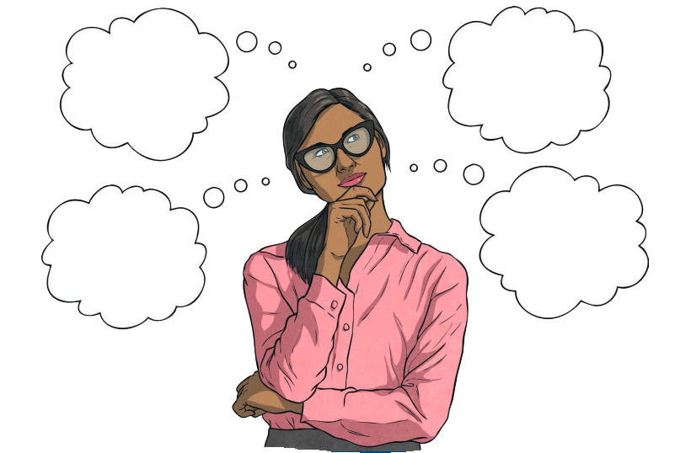
Making Laws and Applying Laws - Revision
1. Note down some reasons in the thought bubbles why we have laws
2. What are three types of civil law?
- ___________________________
- ___________________________
- ___________________________
3. List three examples of criminal law?
- ___________________________
- ___________________________
- ___________________________
4. Label the triangle below to show the Court Hierarchy

Highest Court in Australia

Highest Court in WA

Lowest Court in WA

5.
This arrow shows the direction of ____________________________________

This arrow shows the direction of ____________________________________

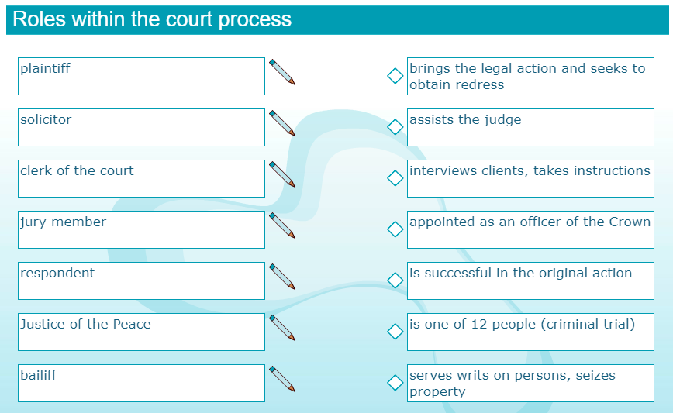
6. Matching the persons with the descriptions that follow:

7. The Right to a Fair Trial - Cloze Activity
Use the Word bank to complete the blank spaces in the text below:

Word Bank

accused defendant equal
fair
innocent
justice
legal proved
punished
unbiased
When a person goes to court for a crime, no matter who they are or what they have been accused of, they are treated as __ __ __ __ __ __ __ __ until the court can prove they are guilty.

In Australia, we have the right to a fair trial or hearing if we have been
__ __ __ __ __ __ __ of a crime. This means the following procedures must be followed in order for the trial to be legitimate:

- the accused or the __ __ __ __ __ __ __ __ __ must be given the opportunity to be represented by a __ __ __ __ __ professional in court.
- All people are considered __ __ __ __ __ before courts and tribunals, by are not discriminated against in any way.
- The accused is given a __ __ __ __ and public hearing before a capable, independent and impartial or __ __ __ __ __ __ __ __ court or tribunal.
- The accused is treated as innocent until it can be __ __ __ __ __ __ beyond reasonable doubt that they are guilty.

These procedures are in place to ensure that __ __ __ __ __ __ __ is served in the courts and that innocent people are not __ __ __ __ __ __ __ __ for a crime that they did not commit.
8. Highlight the correct answer to the following questions.
- The difference between rules and laws is that:
  - laws apply to everyone and rules apply only to certain groups
  - rules have consequences and laws do not
  - laws cannot be broken and rules can be
- Which statement about laws made in Australia is NOT true?
  - Courts make laws called common law, which is inferior to statute law
  - Common law is signed by the governor-general
  - Statute law includes civil law
- When a judge makes a decision on a case that is the first of its kind, it is called:
  - common law
  - case law
  - a precedent
- The order of making laws in Australia is as follows:
- a bill – passed with a majority vote in House of Representatives – agreed to in the same the format – Act of Parliament
- a proposal for a new law – signed by the governor-general – passed with a majority vote by the Senate – Act of Parliament
- a bill – passed with a majority vote in parliament – signed by the governor-general – Act of Parliament
- Statute law applies to everyone and:
- is made by the courts of Australia
- is bound by the Constitution
- is proposed in the upper house
- The law that covers a dispute about something that was bought online is called:
  - contract law
  - tort law
  - statute law
- The law that covers a dispute between a manufacturer and the buyer of their product is called (remember the Donoghue v Stevenson case)
  - contract law
  - criminal law
  - tort law
- Aboriginal and Torres Strait Islander people also use law to govern behaviours. The basis of this law is:
  - only the Dreaming stories
  - only the religious beliefs
  - both the religious beliefs and the Dreaming stories
- In Aboriginal society, the rules of looking after the land, the rules of marriage, and the rules for ceremonies are all aspects of:
  - customary law
  - kinship law
  - Dreaming law
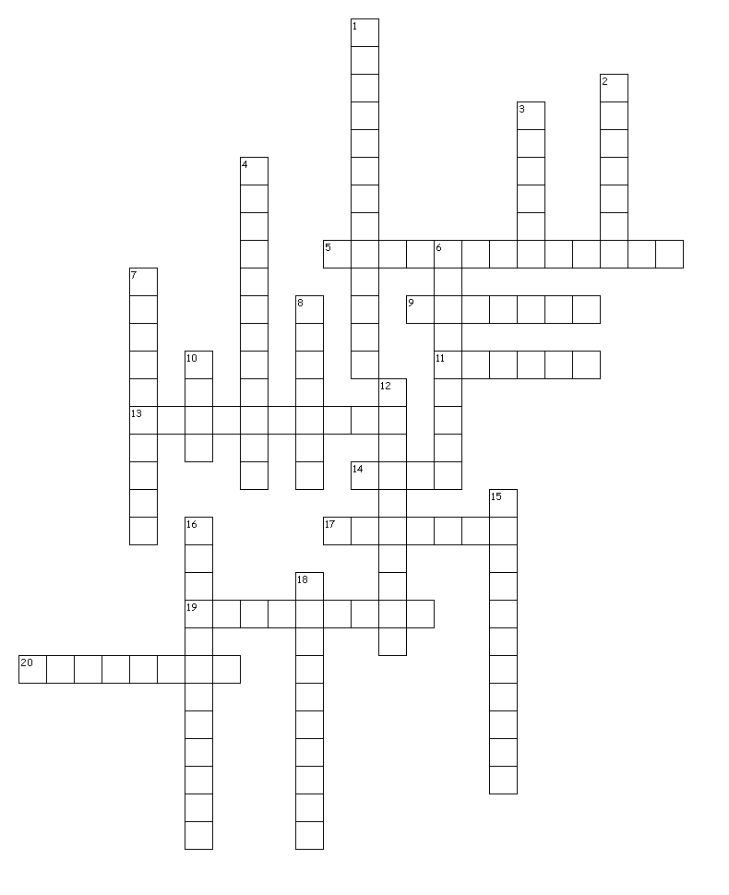
Across
9. Complete the Cross Word using the clues below:
5. The leader of the majority party in the federal parliament (5-8)
9. The highest level of government which acts for the whole country (7)
11. The number of people who make up a jury (6)
13. A Tort that causes injury or loss to one person due to the lack of care by another (10)
14. The legal rules that everyone must follow (4)
17. The type of law created by parliament (7)
19. Found responsible for breaching duty of care after leaving a snail in a bottle of beer (9)
20. The system of courts that interprets and applies the law (8)

Down
1. The Prime Minister (5-8)
2. A physical attack (7)
3. The type of law created by the courts (6)
4. The payment for damages in civil law (12)
6. These should be free, fair, open and regular (9)
7. The elected representatives of the people who govern, make and amend laws (10)
8. The highest court in Western Australia (7)
10. The highest court in Australia (4)
12. A Tort that impacts a person’s good reputation (10)
15. Created by parliament, also known as statute law (11)
16. The crime of killing someone without meaning to (12)
18. The suppression of free speech (10)

